**Lab Exercise 6– Terraform Multiple tfvars Files Objective:**

Learn how to use multiple tfvars files in Terraform for different environments.

**Prerequisites:**

* Terraform installed on your machine.
* Basic knowledge of Terraform configuration and variables.

**Steps:**

1. **Create a Terraform Directory:**

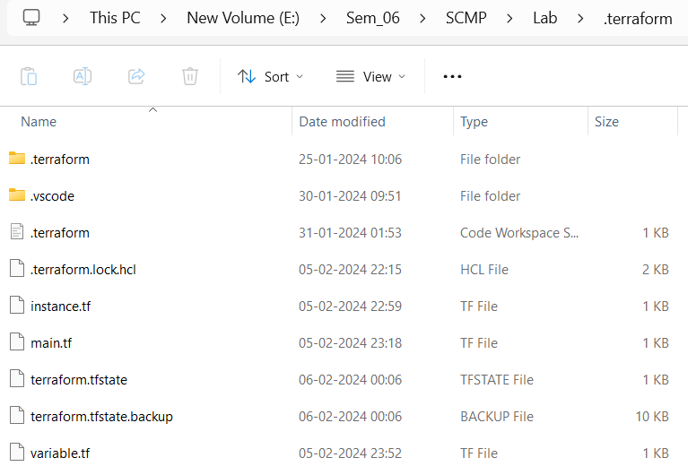

Create Terraform Configuration Files:

* + Create a file named main.tf:

**# main.tf**

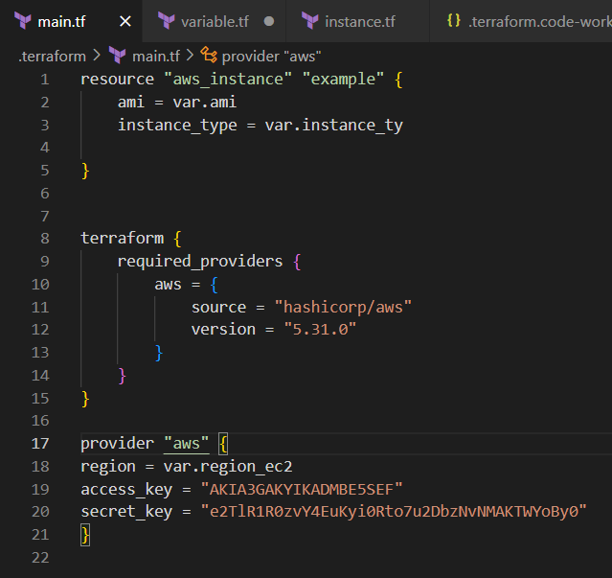

* + Create a file named variables.tf:

**# variables.tf**

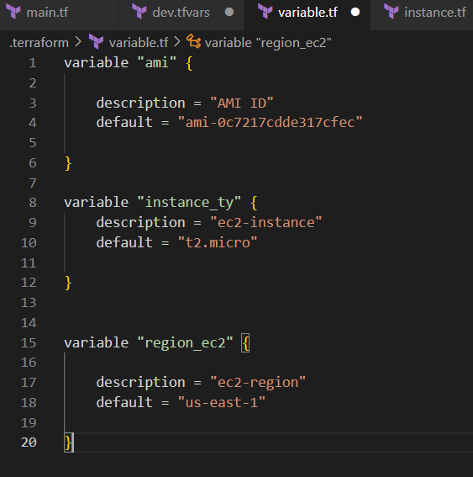

1. **Create Multiple tfvars Files:**

* Create a file named dev.tfvars: **# dev.tfvars** 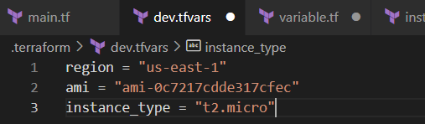
* Create a file named prod.tfvars: **# prod.tfvars**

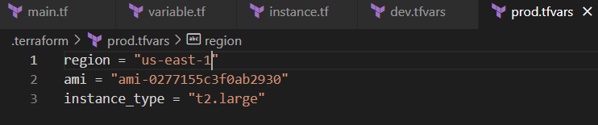

1. **Initialize and Apply for Dev Environment:**

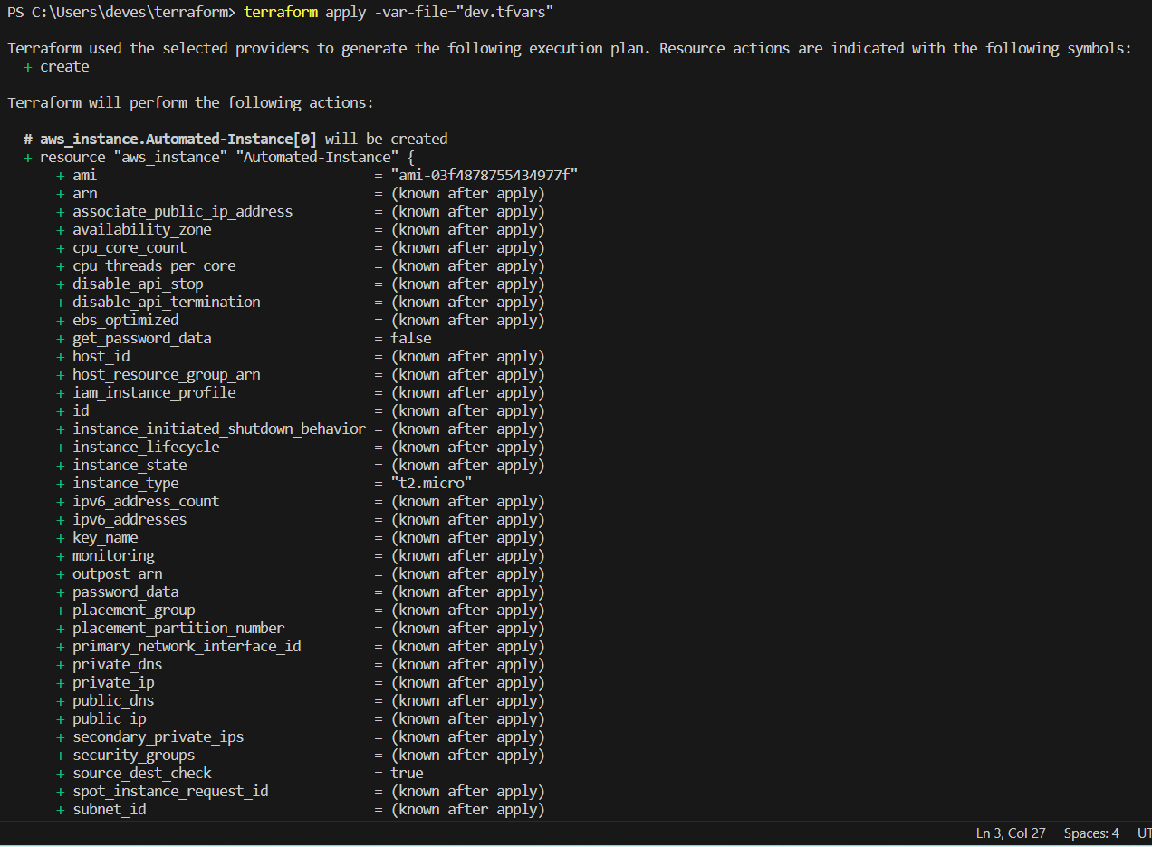

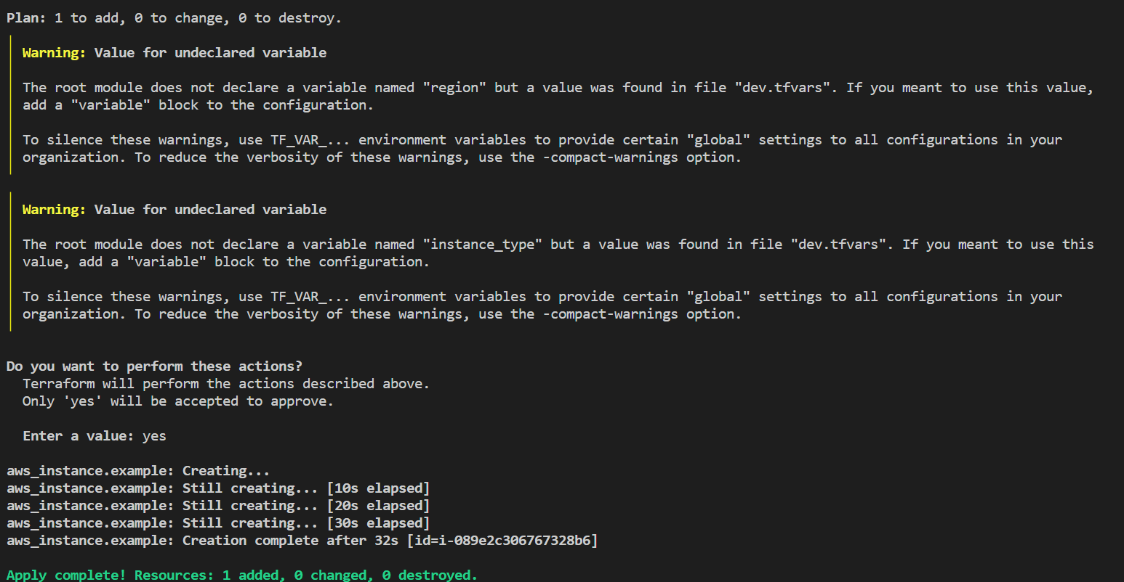

**4. Initialize and Apply for Prod Environment:**

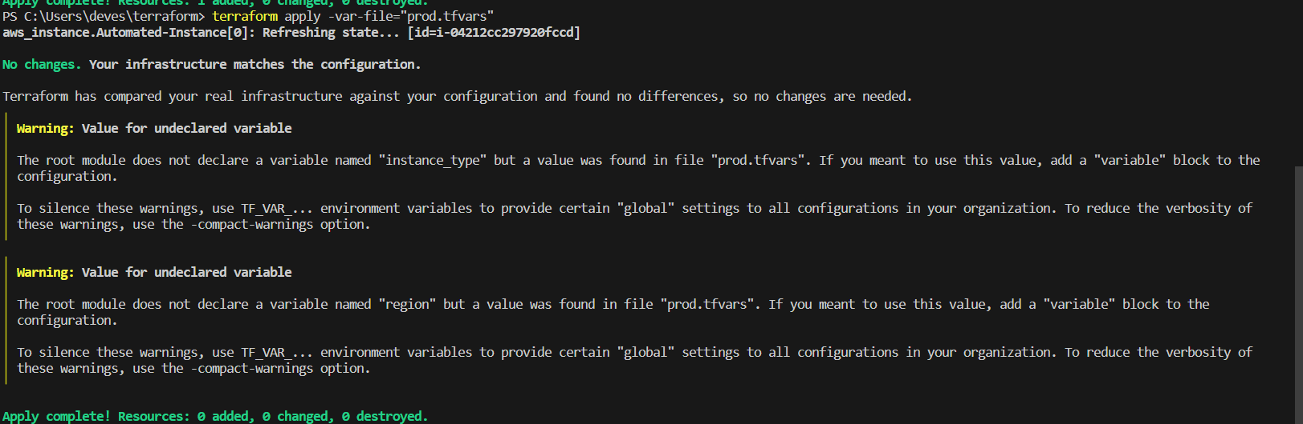

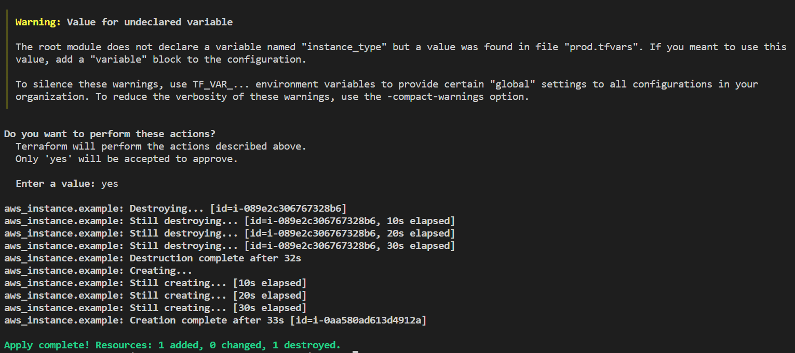

1. **Test and Verify:**

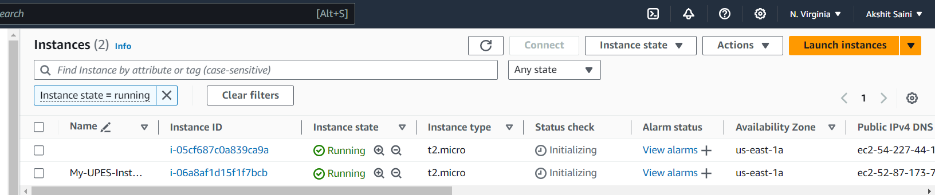

1. **Clean Up:**

